**Abstract**

Keywords: agriculture, agriculture in Nepal, experts and farmers.

**Acknowledgment**

Successfully completion of any type of project require helps from people and their experience. I have also taken help from different people for the preparation of this report. Now there is a little effort to show my deep gratitude to all those who have helped me throughout the project.

I would like to express my sincere gratitude to my supervisor Er. Ajaya Kumar Sharma for providing invaluable guidance, comments and suggestions throughout the course of the project. Also I would also like to thank Mr. Shravan Kumar Bist who cooperated during the interview and all my friends who helped me during the surveys.

**Table of Contents**

​ 1. Introduction 5

​ 1.1. Background 5

​ 1.2. Problem statement 5

​ 1.3. Proposed solution 5

​ 1.4. Aim 5

​ 1.5. Objectives 5

​ 1.6. Structure of report 6

​ 1.6.1. Introduction 6

​ 1.6.2. Project Plan 6

​ 1.6.3. Literature Review 6

​ 1.6.4. Market Search 6

​ 1.6.5. Artifact Planning 6

​ 1.6.6. Critical Analysis 6

​ 1.6.7. Conclusion 6

​ 1.6.8. References 6

​ 1.6.9. Appendix 6

​ 1.7. Significance of study 7

​ 2. Project Plan 7

​ 2.1. Project plans 7

​ 2.2. Gantt Chart 7

​ 2.3. Work breakdown 8

​ 3. Literature review 9

​ 3.1. Agriculture: 9

​ 3.2. Importance and need of agriculture with growing population: 9

​ 3.3. Economic growth with agriculture: 10

​ 3.4. Challenges for global agriculture: 10

​ 3.5. Adaptation of Technology in Agriculture 10

​ 3.6. Agriculture in Nepal 11

​ 3.7. Importance of agriculture for Economic growth in Nepal 11

​ 3.8. Major challenges in agriculture in Nepal 11

​ 3.9. Foreign employment trend for youth and low skilled human resources in agriculture in Nepal 12

​ 3.10. Current status of agriculture in Nepal 12

​ 3.11. Need of Online mobile application platform 12

​ 3.12. Mobile application development 13

​ 3.12.1. Native Apps 13

​ 3.12.2. Web Apps 13

​ 3.12.3. Hybrid apps 13

​ 3.13. Tools and technologies used in this project 14

​ 3.13.1. Dart 14

​ 3.13.2. Flutter 14

​ 3.13.3. Firebase 14

​ 3.13.4. Visual Paradigm 14

​ 3.13.5. Balsamiq Prototyping 14

​ 3.13.6. Visual Studio Code 14

​ 3.13.7. Agora 14

​ 4. Market Research 15

​ 4.1. Secondary Market Research 15

​ 4.1.1. Hamro Krishi (10k+ downloads, size 8.7 MB, 4.2 rating, 65 reviews) 15

​ 4.1.2. Smart Krishi (100k+ downloads, size 11.49 MB, 4.4 rating, 2k reviews) 16

​ 4.1.3. Krishi Guru (100k+ downloads, size 8.5 MB, 4.5 rating, 483 reviews) 17

​ 4.1.4. Krishi TV (5k+ downloads, size 11 MB, 2.4 ratings, 21 reviews) 17

​ 4.1.5. Summary: 18

​ 4.2. Primary Market Research 18

​ 4.2.1. Survey 18

​ 4.2.2. Data Analysis 20

​ 4.2.3. Interviews 26

​ 5. Artifact planning 27

​ 5.1. System requirements 27

​ 5.1.1. Functional Requirements 27

​ 5.1.2. Non-functional Requirements 27

​ 5.2. Methodology 27

​ 5.2.1. Research methodologies 27

​ 5.2.2. Development Methodology 27

​ 5.3. Languages and frameworks 28

​ 5.3. System design 28

​ 5.3.1. Use case diagram 28

​ 5.3.2. Activity diagram 31

​ 5.3.3. Class diagram 32

​ 5.4. Prototypes 33

​ 5.4.1. Prototypes of farmers. 33

​ 5.4.2. Prototypes of Experts 34

​ 5.5. Testing Strategies 34

​ 5.5.1. Unit testing 35

​ 5.5.2. Integration testing 35

​ 5.6. Evaluation Strategies 35

​ 6. Critical analysis 35

​ 7. Conclusion 35

​ 7. References: 35

​ 8. Appendix: 39

​ 8.1. Appendix 1: Prototypes 40

​ 8.2. Appendix 2: Progress Reports 41

# 1. Introduction

## 1.1. Background

Agriculture is the most important thing for every living being. Everyone need food to survive and perform daily tasks. It is the major sector which provides highest economy to most of the developing nations. Agriculture is the primary source of livelihood for most of the people in Nepal. However this sector has not perform well as compared to other sectors of Nepal. In the recent years agricultural practices has been uplifting with time. With the evolution of smart phones, people are surfing internet for getting valid information and understanding modern technologies that can add value to their farm. So the technologies advancement has bought a great opportunity in the agricultural sector. It’s time to reduce a labor intensive farming and practice modern methods by adapting technologies.

## 1.2. Problem statement

With the rapid population growth the need of food is growing day by day. But the condition of food producer has not been uplifted with time. The farmers of Nepal are still practicing traditional method of farming which will not fulfill the demand of consumers in the upcoming years. The major reasons for this are: lack of information services, lack of farm managerial skills, lack of knowledge and inefficient technology. There are existing applications like Hamro Krishi, Smart Krishi, Krishi Guru who are trying to overcome these problems. But, there is no any online platform in Nepal through which farmers can directly communicate with the experts by which they can consult to solve their farms problems and uplift their skills in farming. For now farmers used to communicate with experts through direct phone call or social media platforms.

## 1.3. Proposed solution

Kishaan will be an android and IOS mobile application that will helps farmers and experts to connect each other. Farmers can directly interact with respective experts to solve their farm problems. Farmers will have multiple options to choose the experts. All the experts will be registered manually looking at their qualification and experience. Before requesting for the service farmers can see the experts that includes qualifications, ratings, experience etc. This solution can help to fill above mentioned information, skill and technology barrier to a certain extent.

## 1.4. Aim

* To build a platform to connect farmers and experts.

## 1.5. Objectives

* To build platform for agriculture experts for providing both online and on-field support.
* To provide valid information to the farmers.
* To aware farmers for adapting modern method of agriculture.
* To provide news and updates.

## 1.6. Structure of report

### 1.6.1. Introduction

Introduction of the report contains the basic research background, problem statement, proposed solution, aim and objectives.

### 1.6.2. Project Plan

The project plan contains all the plans related to the project. It includes gantt chart, work breakdown structure and full project planning structure.

### 1.6.3. Literature Review

Under the literature review section, all the theoretical and practical topics related to the project are described in details.

### 1.6.4. Market Search

Market research contains both primary and secondary market research. Primary research contains surveys and interviews whereas secondary market research contains detail research on existing mobile application on the agriculture domain.

### 1.6.5. Artifact Planning

This section includes functional and non functional requirements, user case diagrams, activity diagrams, class diagrams, ER diagram, Prototypes and some testing strategies.

### 1.6.6. Critical Analysis

The critical analysis section includes the detailed examination and evaluation of research outcomes.

### 1.6.7. Conclusion

This section contains conclusion based on research.

### 1.6.8. References

All the references are included in this section.

### 1.6.9. Appendix

Apart from full report section, some of the elaborated contents are mentioned here.

## 1.7. Significance of study

After the completion of project, the system will solve a communication gaps between farmers and experts. Those who are researching in the agriculture can get a proper documentation on condition of farmers and experts in the country with internet penetration and it’s adaptation.

# 2. Project Plan

## 2.1. Project plans

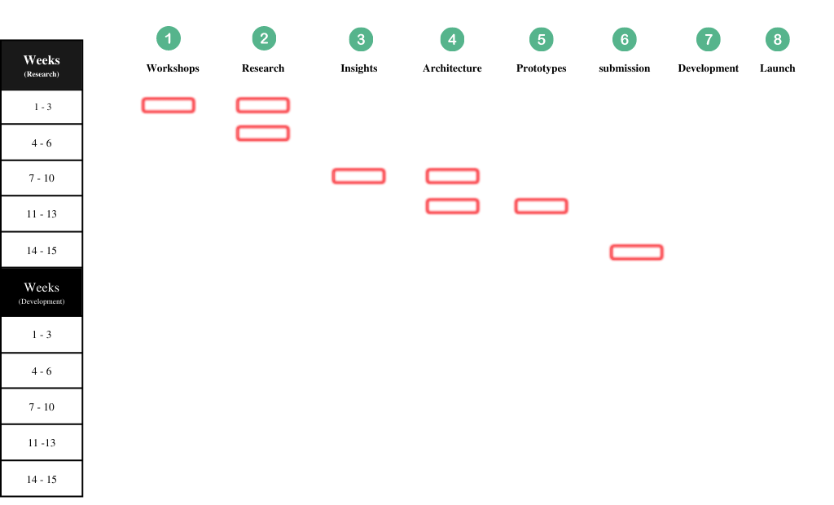

## 2.2. Gantt Chart

The below the Gantt chart which contains all the project schedules from week 3 to week 15.

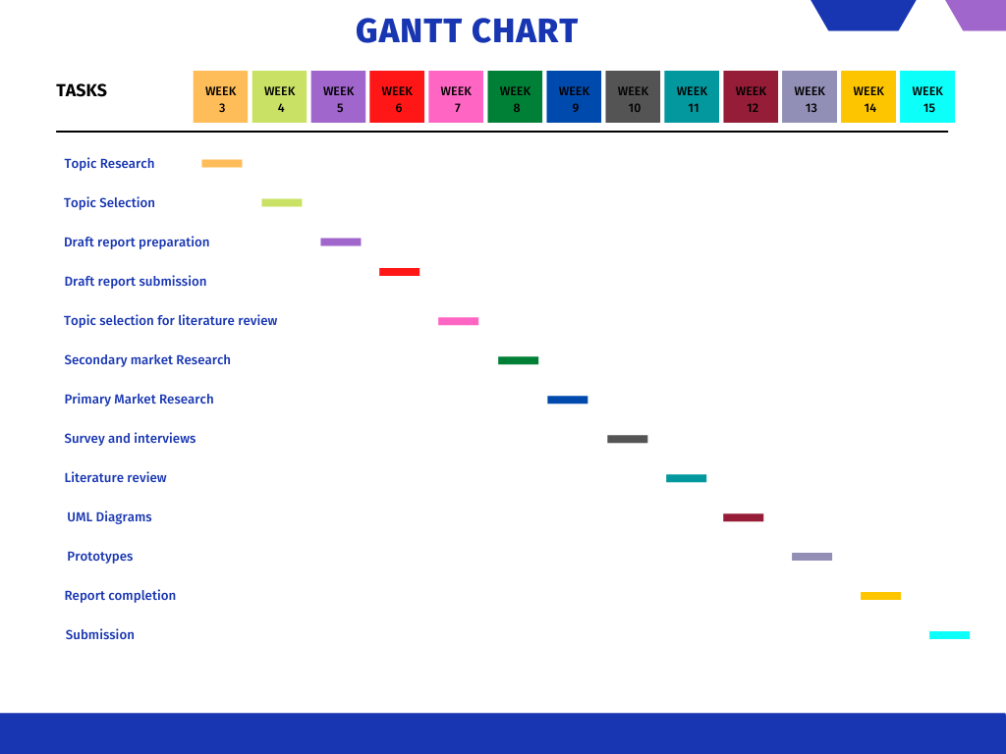­

Fig 1: Gantt chart

## 2.3. Work breakdown

The below is the work breakdown structure of whole research project.

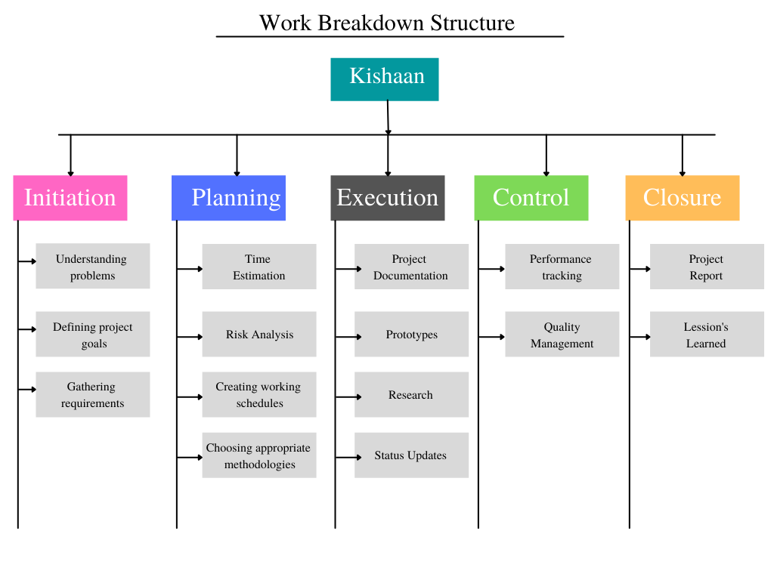

Fig 2: Work breakdown structure.

# 3. Literature review

## 3.1. Agriculture:

The production of food and other products by plating crops and rearing animals is known as agriculture. The major areas of agriculture includes crop farming, livestock, forestry and aquaculture. About 75% of the world’s poor population lives in rural areas and out of them about 86% of the people fully depends on agriculture for their livelihood (FAO. 2021). It is one of the most common land use types, covering 4.9 billion hectares (or 38 percent of the Earth's land surface) (Andrade, Pasini and Scarano, 2020). Innovation in agriculture is mostly associated with technology. Farmers have adopted more technology in their pursuit of higher yields over the centuries. Different types of farming practices has been used over the years. There is a concept of smart farming these days. Smart Farming is essential for addressing a variety of agricultural concerns, including productivity, environmental impact, food security, and sustainability (Gebbers and Adamchuk, 2010). The technologies like remote sensing, IoT, cloud computing, and big data analysis have the potential to generate new applications and services that improve agricultural productivity and food security by better understanding climatic conditions and changes (Kamilaris and Prenafeta-Boldú, 2018).

## 3.2. Importance and need of agriculture with growing population:

The agriculture industry has drastically changed over the past 50 years. It is the most important domain for every living being. It is a part of who we are, our habits and culture. Improvement in agriculture and food system improves the living standard and health of the people (Nations, 2018). As we know that population explosions are temporary. Most of the countries of the world are approaching towards the end of rapid population growth. According to UN population Division, the population is estimated to be 10.9 billion by the end of 2100 (Roser, 2019). The below figure is the estimation population projection for 2100. we can see that the global population is slowing but the population of Asia and Africa will still be increasing. To fulfill growing demand, agricultural output in Sub-Saharan Africa and South Asia would need to more than double by 2050, while in the rest of the world, the estimated rise would be only one-third higher than current levels (Food and Agriculture Organization of the United Nations, 2017).

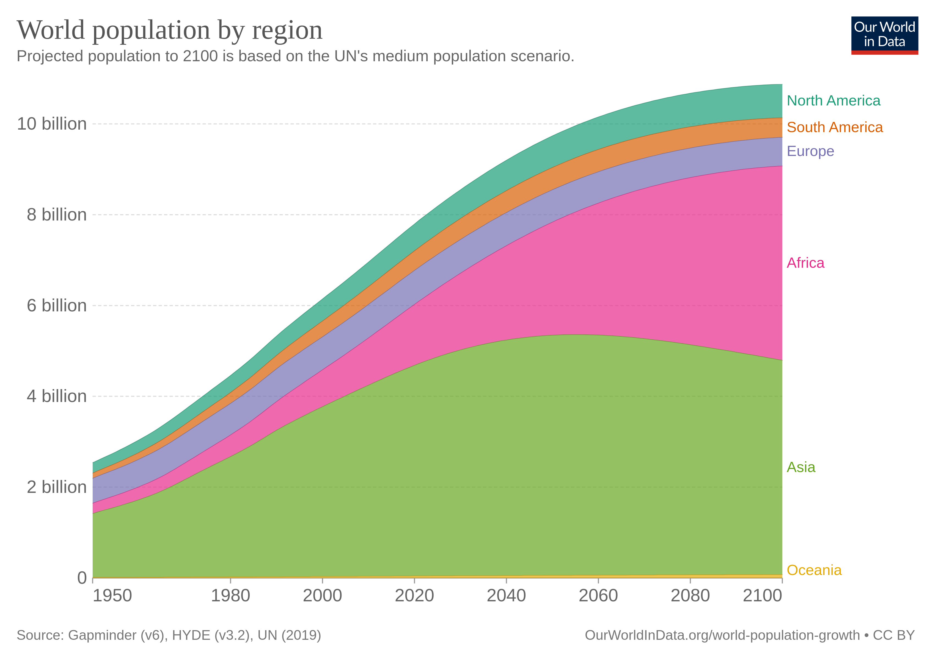

Fig 3: World population by region between 1700-2100 by UN population division 2019.

## 3.3. Economic growth with agriculture:

Agriculture is extremely important to the world economy. With the continued expansion of the human population, pressure on the agricultural sector will increase. It is such a domain which have the capacity to reduce poverty, improve standard of living and food security for 80% of world’s poor who are involved in farming (The World Bank, 2018). Agriculture contributes about 4% to global GDP and more than 25% to some developing countries (The World Bank, 2018). According to the FAO publication World agriculture towards 2030/2050,the global economy will increase at a pace of 2.7 percent per year. As a result, global GDP from agriculture would rise from over US$50 trillion in 2005–2007 to nearly US$126 trillion in 2050 (at constant 2005 prices) (Food and Agriculture Organization of the United Nations, 2017).

## 3.4. Challenges for global agriculture:

Around one-third of all food produced is lost or wasted somewhere throughout the food chain, from production to consumption (HLPE, 2020). The world's population is rapidly expanding, and as a result, the need for food is rapidly increasing. Farmers' traditional methods are insufficient to meet rising demand. The major challenges for global agriculture for 21st century are: food security, poverty management and sustainable natural resource management (Mccalla, 2001). The importance of time cannot be overstated. Current trends in natural resource depletion show that rainfed and irrigated agriculture production is approaching or beyond the sustainability limit. The expansion of agricultural productivity depends on increased land utilization, irrigation, and agro-chemicals. The intricate feedback loops between climate and land, expose agriculture to higher levels of risk, which must be handled (FAO, 2021). For food security and long-term production, increasing land and water productivity is critical. However, Agriculture also have damaged our environment through deforestation, nitrate pollution, emission of green house gases, land degradation, over extraction of ground water and so on. To solve these issues, a greater understanding of agricultural ecosystems that are complex, multivariate, and unpredictable is required.

## 3.5. Adaptation of Technology in Agriculture

Innovation of technologies have changed the face of agriculture throughout the time. Looking at the current trends, the future of agriculture will fully depends on technology. The farmers have adapted more technologies compared to past. The advancement of technology has bring a great revolution in agriculture and highly impacted the farmers life. With the introduction of technology in this digital era, we humans have pushed the boundaries of our thinking processes and are attempting to merge a natural brain with an artificial one. Nowadays technologies like robots, temperature and moisture sensors, GPS, and aerial images are used in the modern farms for efficient, profitable, safer and environmental friendly agriculture (USDA, 2018). Farmers don’t have to apply water, fertilizers and pesticides by themselves. Instead they can simply use a robotics technology to do all those tasks automatically. They also enable more reliable monitoring and management of natural resources. The demand of food is growing but the supply facing constraints in land and farming inputs. Nowadays agriculture can be easily done using data and connectivity. There are techniques like: artificial intelligence, analytics and other emerging technologies that could help to increase production and improve efficiency. Agriculture is less digitalized compared to other industries. However if there will be a successful implementation of connectivity then agriculture industry have the capacity to add extra $500 billion to global GDP by 2030 (Goedde, Katz and Revellat, 2020).

## 3.6. Agriculture in Nepal

Nepal is an agricultural country. It is a major source of food, income and employment in the country. However we still rely on other countries. Climatic diversity even in a small area is a unique geographical feature of Nepal (Acharya and Kafle, 2009). The farming patterns and production of the country differs with ecological regions. The development of agriculture seems to be unsatisfactory with increase in population. Government has implemented different policies and programs to boost agriculture in the country. But due to the lack of technology, market access, transportation and irrigation there is a little hope for desire outcome (Poudel, 2020). Most of the farmers in rural areas of Nepal are smallholders who practice labor intensive farming and follow traditional method of farming. Majority of them practice subsistence farming in which work load is high and production is low. In some areas the agricultural practices has updated, management practices has changed, modern technologies and effective programs has launched, more focused on budget allocations but the pace of agricultural development has not perform as expected (Gyawali and Khanal, 2021).

## 3.7. Importance of agriculture for Economic growth in Nepal

Agriculture contributes about 23.13% to the nation GDP which ranks 20th in global country rankings and 4th in Asia ranking (TheGlobalEconomy.com, 2020). About 60 percent population of the country depends on agriculture for their livelihood (The Kathmandu Post, 2021). The agriculture sector of Nepal is important to increase the income, remove poverty and to improve the living standard of the people because about 2/3 of Nepalese are involved on it. In case of Nepal, we can say that poverty is the product of unproductive agriculture. There is a very low agricultural productivity in the country but there is a great potential for rapid development and improvement through modern tools and technologies (Joshi, Conroy and Witcombe, 2019). Covid-19 has disrupted a global economy. Due to shutdown most of the farmers didn’t get the market to their production. This has highly affected the livelihood of the farmers as well as to the national economy.

## 3.8. Major challenges in agriculture in Nepal

The major challenge for the Nepal government and policy makers is to boost productivity in agriculture sector and thereby to meet the high food demand in the country. With growing population and increasing food prices the government has the major challenge to maintain balance between policies to food security and policies to improve farmers income. On the other hand, Nepal is a landlocked country. We have a diversified landscape which geographically divided in three regions: Himalayan, Hills and Terai. Frequent climatic change and too much of diversification is the major geographical challenge in the country. The population of the country is increasing day by day and land holdings are fragmented and scattered across the country. Agriculture in Nepal needs to be modernize, diversified and commercialize for sustainable development and to promote export. We have the shortage of distribution, extension channels, knowledge , production and competition. Additionally, there is also lack of storage facilities, right market, proper irrigation and communication (StartupsNepal, 2018). The major challenges that our country is currently facing includes:

* Small productions
* Obsolete technology
* Lack of farm managerial skills
* Fragmented and small sized land
* Policy level constraints
* Lack of information services
* Right market

(StartupsNepal, 2018)

## 3.9. Foreign employment trend for youth and low skilled human resources in agriculture in Nepal

Migration from developing countries to developed countries is a global phenomenon. Likewise in case of Nepal, the foreign employment rate is high. The rate of foreign migration in 2013/14 was 519,638 and in 2018/19 it decreased to 236,208 (Nepal Labor Migration Report, 2020). The Nepali immigrants sent Rs. 961.05 billion in last fiscal year 2020/21 (The Kathmandu Post, 2021), which is all time high in remittance. However the employment rate in the country has not been drastically changed. As per the report of central bank, most rural families depends on at least one member working away from home (Pant, n.d.). The skilled human resource of the country is attracted to developing countries because of better incentives, scholarship and better facilities. In case of Nepal the ratio of technician to farmer is 1:1500 whereas in other developed countries the ratio is 1:400 (The New Humanitarian, 2013). These numbers are too poor for Nepal compared to other developed countries. We are currently in the developing phase but the numbers needs to be changed with time. From Nepal about 250 agriculture graduates, 80 forestry and 70 veterinaries are produced every year, out of which about 30% go to abroad in search of better opportunities (Kattel and Sapkota, 2018). This type of skill resource migration directly affect to the sustainable development of the country. When all the high skilled human resources migrated to developed countries, the low skilled and unskilled human resources can’t uplift the condition of the country. The most of the farmers of the country are illiterate and unskilled. Due to which they can’t adapt modern practices and technologies. The traditional practices will not be changed until and unless there is a skill human resource working together with unskilled, low skilled or semi-skilled human resources.

## **3.10. Current status of agriculture in Nepal**

Traditional agriculture was the dominant type in the past. There was no concept of commercial farming in Nepal. Formulation of different plans and policies in the recent years that aims to provide subsidies, improve irrigation and introducing improved seeds and modern technologies have somehow bought the concept of commercial or modern method of farming (Gyawali and Khanal, 2021). The statistics says that most of the farmers of the country are illiterate. In the recent years the youth are involving in agriculture compared to past, which is one of the benefit for Nepali agriculture. With the establishment of some agri-tech companies in the country they have built some mobile apps and other online platforms to provide information to the farmers. Because of less awareness of farmers with technologies these companies are also not able to impact most of the farmers life technically. The current scenario of farming is fully based on the middleman. From seeding to harvesting farmers needs to depend on middleman.

## 3.11. Need of Online mobile application platform

With the growing number of people using smartphones and tablets to access the Internet, mobile app development offers a unique opportunity to reach a wide range of potential customers (Hilliard, 2014). Nowadays most of the business is shifted to online platform by building their websites. The next phase for them will be developing a user friendly mobile application to build their customer base. In case of Nepal, farmers don’t have access to right technology, technical knowledge and institutional credit (Joshi, Conroy and Witcombe, 2019). The major factors that plays an important role for agricultural productivity would be modern technologies and inputs. So with the help of modern technologies they can easily communicate with the experts and learn more about agriculture. They can also sell their products online.

## 3.12. Mobile application development

According to Statista, in next three years the total number of mobile devices will be increased by 3.7 billion (Qamadness, 2021).

Mobile applications are becoming more popular day by day. Nowadays we have apps for almost everything. From a simple Todo application to large artificial intelligence applications the mobile app world is becoming more vast and friendly. In the early stage people use mobile phone for calls, messaging, clocks, calculator etc. Then there comes the internet based mobile apps. This has revolutionize the mobile app field. With the internet penetration, the mobile application domain has been updated with time. There are mainly three types of mobile applications: Native, web and hybrid applications.

### 3.12.1. Native Apps

These types of apps are created for one specific platform or operating system. Those types of apps are built either for android or IOS but not for both at the same time. We can run native android apps on android platforms and native IOS apps on IOS platform. There is also the benefits of native apps. Because of their single platform focus they are faster and reliable compared to hybrid apps. However writing a native apps means rewriting every code for different platforms. When the user gets an update they have to download the new file and reinstall it. These types of apps are developed by using various programming languages like: Java, Swift, C, C++, React etc.

### 3.12.2. Web Apps

These are the fully responsive websites that can work on any mobile devices or operating system. They response like native apps but they can be access from browsers as well in the mobile devices. They are not the complete mobile application but a response website that adapt interface according to the device. We don’t have to manually install these types of application. We can access them simply by typing an URL in web browser. For these types of apps we don’t need to customize platforms or operating systems. Moreover, user don’t need to download anything to run these types of apps which don’t take any space in the device. However, these types of apps fully depends on browsers. That can sometime cause of problem like if one browser support all the features and functionalities then other may not be capable of supporting them. These types of apps are coded using HTML5, CSS, JavaScript, Ruby and so on.

### 3.12.3. Hybrid apps

These are the combination of native and web apps. They do have app icon, responsive design, better performance and some of them can able to function offline. We can also say that these are the web apps that are made to look native. Building these types of apps are more quicker and economical compared to native apps. These types of apps can be downloaded form play store or apple store. They are write once and run anywhere type of application. Having platform independent they have the single code base, which means there is much less code to maintain. However they have some cons as well. They might lack in power and speed. Technologies used for developing these types of apps includes Ionic, Objective C, Swift, HTML5 and so on.

## 3.13. Tools and technologies used in this project

### 3.13.1. Dart

Dart is an open-source, general purpose, object-oriented programming language developed by Google in 2011 (Java T Point, 2021). it is a client optimized language for developing fast applications for all platforms. We don't need any compiler to compile dart programming language. This program is used to create interfaces for web and mobile apps. It support most of common concepts of programming languages like classes, functions, interfaces.

### 3.13.2. Flutter

Flutter is a open source framework developed by google for mobile user interface. It uses dart as a programming language. Flutter support cross platform which can be write once and run in different platforms. It helps us to develop easy and productive mobile apps for android and IOS. The another part of this is it will remove the development cost.

### 3.13.3. Firebase

Firebase is a Backend-as-a-Sevice that provides variety of tools to develop quality apps to the developers. It is also developed by google. It has a services like analytics, databases, storage, push messaging, authentication and so on (Stevenson, 2018). All of the Firebase services are hosted in the cloud and developer can easily configure them with a single clicks.

### 3.13.4. Visual Paradigm

Visual paradigm is the application that is used to model business information system and manage development processes by software development teams (TRM Mgmt Group, 2021). It provides report and code generation as well. It is used for designing user case diagrams, activity diagrams, class diagrams, database schema and so forth.

### 3.13.5. Balsamiq Prototyping

Balsomiq is a low-fidelity prototyping tool that is used to wireframe software interfaces for mobile, desktop and so on. It includes simple drag and drop features which makes quite easier for everyone to use.

### 3.13.6. Visual Studio Code

Visual studio code is a code editor that is used to write codes for variety of programming languages.

### 3.13.7. Agora

Agora is the real time connection platform which provides different cloud services for both clients and developers.

# 4. Market Research

## 4.1. Secondary Market Research

Secondary market research is performed by exploring existing agriculture apps in Nepal that are found in google play. While performing a research a smart phone (Samsung Galaxy J7 prime) having 4gb of RAM is used. The major apps that are working in agriculture domain in Nepal includes:

* Hamro Krishi
* Smart Krishi
* Krishi Guru
* Krishi TV

(Note: total number of downloads, app size, ratings and reviews are taken from google play.)

### **4.1.1. Hamro Krishi** (10k+ downloads, size 8.7 MB, 4.2 rating, 65 reviews)

* Need to give location, camera, contacts and storage permission to open the application.
* Weather forecasting information for next three days by meteorological forecasting division.
* List of agriculture related questions and answers.
* Weather information about locations. (not working)
* Agriculture experts section. (not working)
* Success stories (only PDF files which even takes long time to load).
* Weather bulletin (only PDF files).
* Publication (includes limited and outdated PDF files).
* List of agriculture offices.
* Market price for 12 different cities are listed but data can’t be fetched from any cities for any crops, meat or fish.
* Information on soil section (only PDF files but files doesn’t load).
* Disease management on crops, birds, animals and fish.
* Agriculture policy (PDF files).
* Help center (a form submission).
* A written article on insurance information.
* Ads running in every pages.

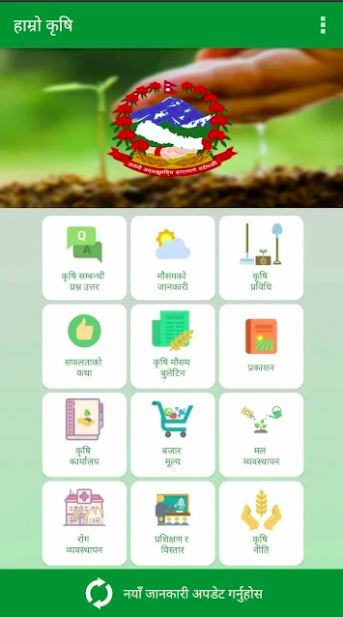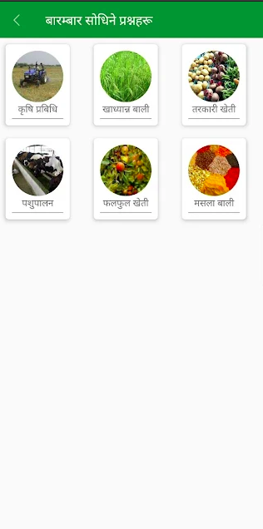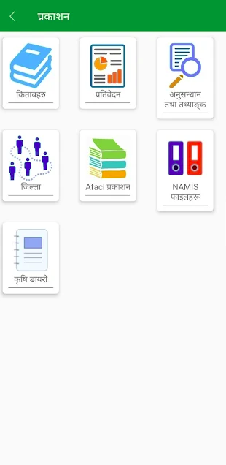

First thing, we can understand an agriculture app needs a location permission to fetch weather data for user current location. But why a simple agriculture app need a camera and contact access? Without giving all the permission we can’t access the system. This may be a privacy concern. Most of the features of the application are missing and outdated. We need to manually update every time to get new information. App is so slow to respond like it sometimes force quit. When user transit from one page to another its reloads every time. The major outcome from the research is, no one has time to wait and see applications loading. Moreover for accessing an information a common user can’t go through the PDF all the time.

### **4.1.2. Smart Krishi** (100k+ downloads, size 11.49 MB, 4.4 rating, 2k reviews)

* Written information on commercial farming about fruits, vegetables, animals, cash crops and food crops.
* Agriculture library where we can find articles about diseases, organic farming, insurance policy and more.
* List of organizations helping in different domain of farming in Nepal.
* Users can read agriculture news.
* Kalimati market rate though its official website.
* Smart tips center where they post certain tips on fruits, vegetables, animals and more.
* Basic land measuring calculator.
* Weather information section (not working).
* Agriculture programs (only a form submission.)
* Ads on different pages.

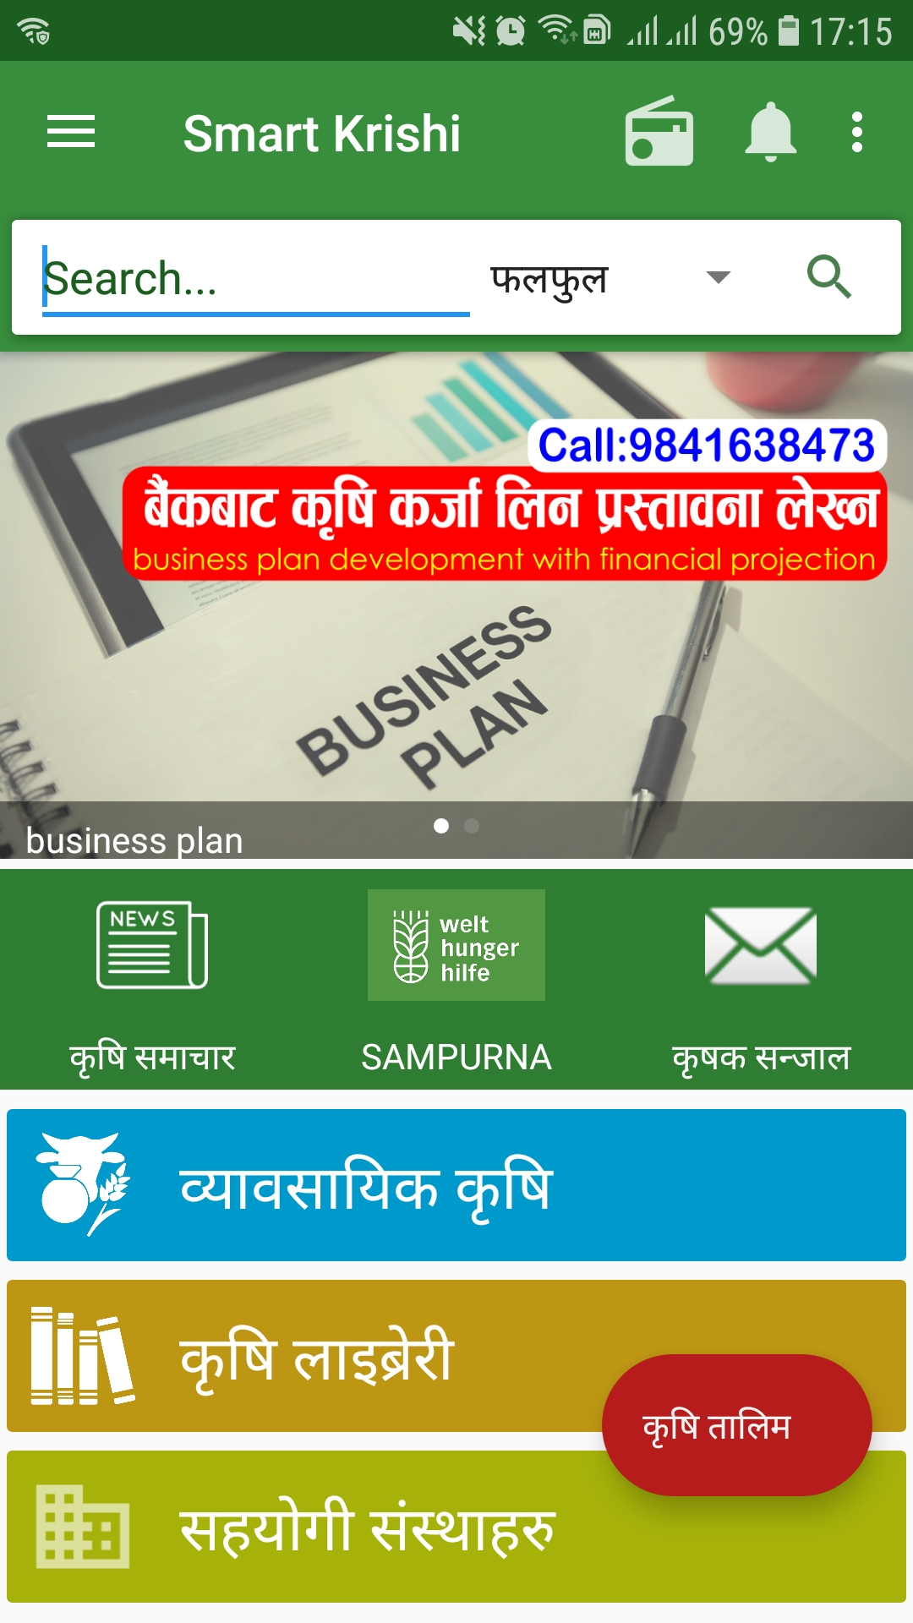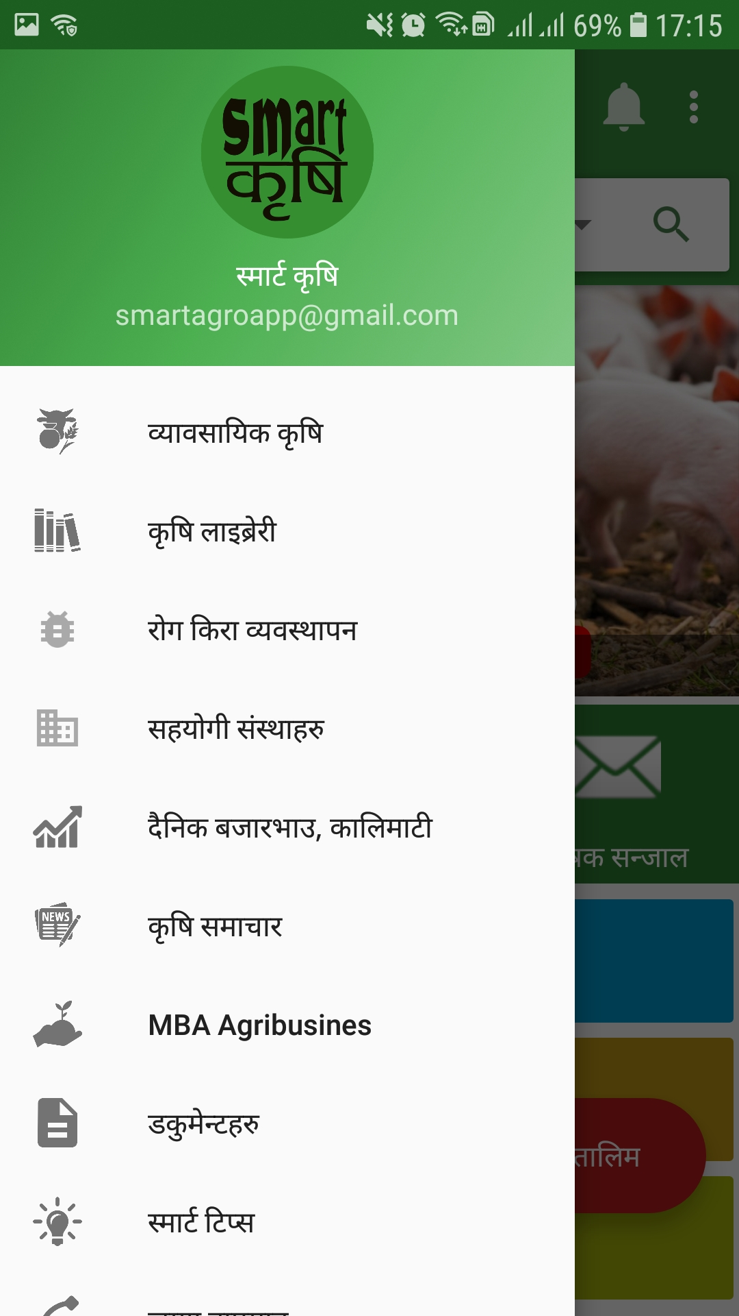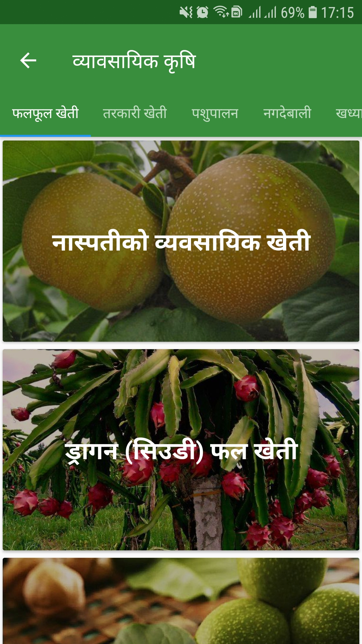

Information on commercial farming is good but we can integrate more subareas. Same for library as well. There are only limited papers that we can access. Information about organizations involved in helping farmers are listed and news are updated from different portals. Only Kalimati market prices are displayed which we can say a limited information. Smart tips center, a concept is good but tips are less. Sometimes a land measuring calculator a good tool. After exploring a doubt comes into the

mind, do any common user prefer to go through papers and articles to understand about his/her need or consult with experts directly which can bring two way interaction?.

### **4.1.3. Krishi Guru** (100k+ downloads, size 8.5 MB, 4.5 rating, 483 reviews)

* Information on commercial farming that includes written documentation on herbs, fruits, vegetables, cash and food crops, etc.
* Agriculture based calculator with multiple features.
* Market that includes buying and selling of products, Kalimati market price, market analysis, list of sellers in different districts and farms.
* Information about events, training’s and Anudan.
* News section is also available.
* Agriculture related videos embedded from YouTube.
* Expert support though SMS for Ncell users.
* Agriculture library that includes multiple articles and blog posts.
* Weather forecasting for next 3 days.

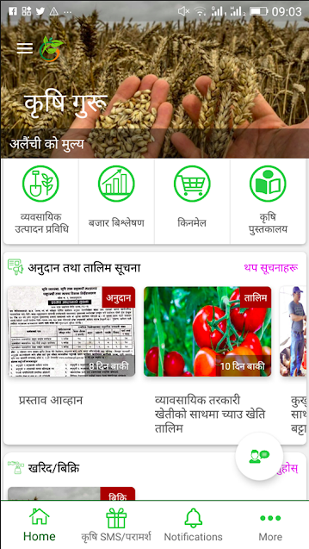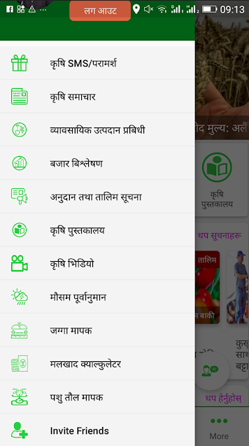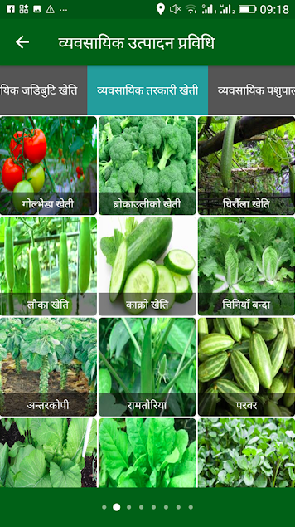

Overall, the system is good compared to Hamro Krishi and Smart Krishi. However there is a problem registering new users. Moreover only Ncell users can get the expert services. As of 2020, Ncell have 17M subscribers and NTC has 22M subscribers (GadgetByte, 2021). This is also the one of major disadvantage for Nepal Telecome users. Market section is there but products are limited and all the products are already sold out.

### **4.1.4. Krishi TV** (5k+ downloads, size 11 MB, 2.4 ratings, 21 reviews)

* Live TV which broadcasts only official krishi TV channel.
* Recorded videos of krishi TV are available.
* Events are scheduled.

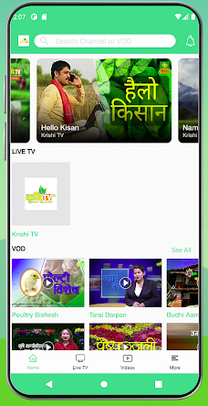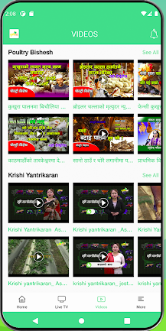

A basic app that broadcasts its personal TV shows. Instead of broadcasting only one channel, multiple agricultural programs from multiple source can be integrated for better user experience. Scheduled events are displayed which is a good feature but user can’t set remainder for the events. Lots of ads kind of irritates users.

### 4.1.5. Summary:

From the research on multiple agriculture related mobile application, 3 out of 4 are fully based on the written information. The information seems to be not updated regularly. The apps lags a lot compared to the other apps from other domains. The information is also quite less. User interface is not that effective and user experience is also quite low. Krishi TV has a better user interface compared to other interfaces but it is also quite slow in processing. These all apps seems to be less effective for the farmers. Because most of the farmers of the country are uneducated, only these written information are not effective. The platform should be build in such a way that there will have to be two way interaction between farmers and experts. Those types of platforms can helps to better understand the farms problems and solve them accordingly.

## 4.2. Primary Market Research

### 4.2.1. Survey

As a part of primary market research, survey is conducted through the google forms. Forms are sent to the respective audience though the different social media platform.

The below are the survey questions and their objectives that has been asked to the farmers.

|  |  |  |
| --- | --- | --- |
| **Farmers survey questions and their objectives** | | |
| **S.N** | **Questions** | **Objectives** |
| 1 | तपाई कुन उमेरको हुनुहुन्छ ?(Which age group best describes you?) | To understand which age groups are mostly involved in agriculture. To get to know whether youth are involved on it or not. |
| 2 | तपाईको उच्च शिक्षा कति हो ? (What is your highest level of study?) | To know about farmers qualification and find the literacy rate in farming. |
| 3 | तपाई के मा आबद्द हुनुहुन्छ ? (What are you farming?) select all that apply. | To know what types of farming they do which will help us to target them accordingly. |
| 4 | तपाई कृषि क्षेत्रमा लागेको कति वर्ष भयो ? (From how long have you being doing agriculture?) | To know how experience they are in the agricultural field. |
| 5 | तपाई सूचनाको पहुचमा कत्तिको हुनुहुन्छ ? (Do you have access to valid information?) | Are they in a range of getting the valid information. |
| 6 | के तपाईको खेतिमा रोग लागने समस्या छ ? (Are you affected by any disease while farming?) | To understand they face problems of diseases while doing farming. If so they need a right consulting and pesticides. |
| 7 | तपाई Mobile app हरु संग कत्तिको परिचित हुनुहुन्छ ? (How familiar are you with mobile apps) | To know whether the farmer have previous experience of using mobile apps. |
| 8 | तपाईले परामर्स कसरी लिदै आउनु भएको छ ?(How do you take experts supports? select all that apply) | To understand the current scenario and trend that farmers use to contact experts. |
| 9 | कृषिबाट तपाईको बार्षिक आम्दानी दर कति हुन्छ ? (What is your annual estimated earning from agriculture?) | To know what types of agriculture they do. |
| 10 | कृषि गर्नुमा तपाईको मुख्य उदेस्य के हो ? (What is your main motive of doing agriculture?) | This can clarify the doubt of whether they do agriculture for personal feeding or commercially for generating income. |
| 11 | के तपाईको उत्पादनले सहि बजार पाएको छ? (Are you getting a right market to your production?) | Are there production going waste or they get a right market which give them a handsome revenue. |
| 12 | तपाई कृषि क्षेत्रको विकासलाइ कसरी हेर्नुहुन्छ ? (How do you look at the pace of agriculture development in Nepal?) | To understand the current scenario in agriculture from farmers prospective. |
| 13 | तपाईको अनुसार नेपालमा कृषि गर्दा आउने समस्याहरु के के हुन्?(According to your experience, what are the major challenges that you see in agriculture sector in Nepal?)(select all that apply.) | To know what they have faced or experience till now. |

The below are the survey questions and their objectives that has been asked to the experts.

|  |  |  |
| --- | --- | --- |
| **Expert survey questions and their objectives** | | |
| **S.N** | **Questions** | **Objectives** |
| 1 | Which age group best describes you? | To understand which age groups are mostly involved in providing support to the farmers. |
| 2 | What is your highest level of study? |  |
| 3 | Mention your area of expertise. | To know their domain of expertise so that they can provide service accordingly. |
| 4 | How many years of working experience do you have? | To know about the experts working experience. The working experience will help to pick out the right candidate for the service. |
| 5 | Have you heard about any online platforms to connect directly with farmers? | To know whether they have used any online platforms before for providing the service. |
| 6 | If you have heard, Please mention the application or platform names? | To know all the existing platforms. |
| 7 | Are you with some companies or selling service independently? | To know about the current condition of expert. |
| 8 | In your thought, what do you prefer working with online platform or selling your service independently? | To know expert interest. |
| 9 | What is your annual estimated earning from agriculture service? | To understand how many help request they get from farmers. And do they need to depend on other works to run regular life. |
| 10 | How do farmers contact you for the service? | Currently how do farmers contact experts for the service. Direct phone calls, SMS, social media and so forth. This helps to know about the current trends as well. |
| 11 | How do you look at the pace of agriculture development in Nepal? | To understand the current scenario in agriculture from experts prospective. |
| 12 | According to your experience, what are the major challenges that you see in agriculture sector in Nepal?(select all that apply.) | To know what they have faced or experience till now. |

### 4.2.2. Data Analysis

Data analysis of farmers.

|  |  |
| --- | --- |
|  | Out of 20 responses, the age group is distributed. 25% of age group between 18-25 years. Other 25% of 35-45 years, another 25% are of above 45 years and 20% are of 25-35 years and rest are below 18 years. |
|  | 46% have less than high school diploma. About 18% have bachelor’s degree. 21.4% have some college degree but no degree. 10.7% have high school diploma. And out of 28 only 1 have master’s degree. |
|  | Most of the farmers are into crop farming, poultry, animal husbandry and horticulture. |
|  | Most of the farmers have above 10 years of experience in the field. And there are 28.6% who are new to the agriculture with below 2 years of experience. |
|  | Only about 46% have access to the valid information whereas rest are not getting it properly. |
|  | About 70% farmers have to regularly fight with the crop disease. |
|  | There are the equal number of farmers who are familiar with mobile apps and not familiar with mobile apps. |
|  | Most of the time farmer either directly phone call or use Facebook to take expert support. |
|  | Most of the farmers of the country are earning around one lakh a year. |
|  | Most of the farmers are doing agriculture for both personal feeding and generating revenue. |
|  | Half of the total farming are not getting the right market to their production. |
|  | Most of the farmers think the pace of agriculture development is slow as compared to other developing countries. |
|  | Traditional method of farming and lack of proper market seems to the major challenge in agriculture in Nepal. Apart from these lack of irrigation facility, poor infrastructure development, unequal distribution of land and illiteracy also comes afterwards. |
| From the farmers analysis, we can see that age group is distributed and most of them are illiterate. Farmers produce goods for both livelihood and earning revenue. However most of them are not getting the right market to their production. Due to the unavailability of platforms farmers directly connect with experts though phone calls. | |

Data analysis of experts.

|  |  |
| --- | --- |
| Outcome | Analysis |
|  | Most of the experts are between 18-25 years and 35-45 years. |
|  | Most of the experts have bachelor’s degree, some have high school diploma and others have gone to some college but no degree. |
|  | This slows that experts have diversified. Out of total there are 2 experts each for rich and animal. The other experts who responded to the form are plant pathologist, aquaculture and mushroom expert. |
|  | Most of the experts have below 2 years of experience. 17.6% have above 10 years of experience, 11.8% have 2-5 years of experience and 11.8% have 5-10 years of experience. |
|  | About 70% have heard about online platforms where 30% don’t have heard about any online platforms. Krishi guru is the most heard online platform. Apart from this expert have also heard of smart krishi, geo krishi, hamro krishi and kheti. |
|  | Most of the experts have involved with company and selling service independent as well. |
|  | Most of the experts also wanted to work with online platforms as well as independently. |
|  | The average estimated earning of expert annually seems to be in between 50 thousand to 1 lakh. Some are earning more and others are earning less than that. |
|  | About 90% of experts get direct phone call for the service. |
|  | Most of the experts rate the pace of agriculture development is medium as compared to other developing countries. However 35% still thinks the pace is quite slow compared to developing countries. |
|  | Experts think the poor infrastructure development and lack of proper market are the major challenges in agriculture in Nepal. |
| Most of the agriculture experts are of young age. Most of them have bachelor’s degree and heard of some online agriculture platforms such as krishi guru, smart krishi, etc. They believe that poor infrastructure, lack of proper market and all others mentioned in the questions are the major challenges in agriculture sector in the country. | |

### 4.2.3. Interviews

Interview is conducted face to face with the expert.

|  |  |  |
| --- | --- | --- |
| **Interview Sheet for agriculture experts**  **Name**: Shravan Kumar Bist **Date**: 1st December, 2021  **Address**: Kritipur, Kathmandu  **Degree:** Master’s in aquaculture | | |
| **S.N.** | **Questions** | **Responses/Comments** |
| 1 | How do yo look at the status and current scenario of agriculture in Nepal? | As compared to other countries the pace of agricultural development is slow in Nepal. The major reason for this is due to traditional farming and high illiteracy rate among farmers. According to him, farmers of many rural areas hesitate to follow the new trends and technologies. They practice labor intensive farming in which work load is high and production is low. In the recent years government has formulated the different plans and policies. These ‘Anudan’ policies has somehow impacted the life of farmers. But we have the culture of ‘Nepotism’. Most of the farmers who actually needs ‘anudan’ are not getting it. However the people(farmers) who are close to the political leaders are getting it. There is a shortage of seeds and fertilizers in most of the seasons. Due tot he unavailability of right seeds, the production is low. Apart from this he also added, farmers are not getting the right market for their production due to middleman’s. |
| 2 | What do you think about technology advancement and software development in agriculture in Nepal? | Technology has a great impact on agriculture. Most of the farmers of the country are either poor or lower middle class. The cost of modern technologies are high. This creates the barrier between technology and farmers, he added. Government is providing tractors and other machines but they are not utilized properly because of lack of knowledge. On case of software development in agriculture, multiple agri-tech startups like hamro krishi, krishi guru and so forth are working on it but these models are still not sufficient to develop and improve the agriculture status of the country. These are just a software models which are not go to models for every-day's life, he also added. |
| 3 | In your opinion, what will be the future trends and technologies in agriculture in Nepal? | Nowadays people are more into indoor farming. People prefer to have their own kitchen garden in their ceiling or in some areas in-front of their house in places like Kathmandu. And the organizations will also be more focused on providing all the services from one roof. Providing seeds to support to market facility. So that farmers don’t need to go to other places for different kinds of products. Everything will be available in one place. |

# 5. Artifact planning

## 5.1. System requirements

### 5.1.1. Functional Requirements

* Farmer must be able to register into the system using their phone number and password. Both must be validated.
* After the successful registration farmers and experts must be able to login from both android and IOS devices.
* After successful login farmer must be redirected to explore screen where there will be the list of all the experts related to different categories.
* Farmers must be able to visit their profile and see their details.
* Farmers must be able to chat, audio or video call experts as per their requirements if experts accepts the request.
* Farmers must be able to search the experts by their name or domain of expertise.
* Farmers must be able to add experts to their favorite list.
* Farmers must be able to view notifications.
* Farmers must be able update their profile information.
* Experts must be able to request for the registration.
* Experts must be able to accept chat, audio and video request.
* Expert must be able to update their profile.
* Expert must be able to add works to favorites.

### 5.1.2. Non-functional Requirements

* The app must have a simple and clean user interface.
* The app must be responsive.
* The app must handle more than 300 requests at a time.
* The app must have good performance and reliability.
* The app must be secure.

## 5.2. Methodology

### 5.2.1. Research methodologies

Quantitative and qualitative research methodologies has been used through out the research process. Quantitative research has been used to collect information about farmers and experts. The process involves interview, online polls and online surveys.

### 5.2.2. Development Methodology

Agile software development methodology will be used to develop the application. This method will be used because the requirements may change with time. The project management process will go through:

* Requirement analysis (understanding application feature requirements through research outcome )
* Design (prototyping using Balsomiq and designing system using visual paradigm)
* Development(coding using dart and flutter)
* Testing (unit, integrated)
* Deployment (releasing app on google play, app store)

## 5.3. Languages and frameworks

Dart as a programming language and Flutter as a framework will be used to develop the application. Apart from these Firebase will be used as a backend infrastructure, Agora SDK will be used for messaging , audio and video calling.

## 5.3. System design

### **5.3.1. Use case diagram**

There will be three actors in the system. They are farmers, experts and admin. Farmers and experts both need to register into the system before accessing the home page. Expert can chat to the farmers after accepting request.

The other is the admin who has the superuser permission.

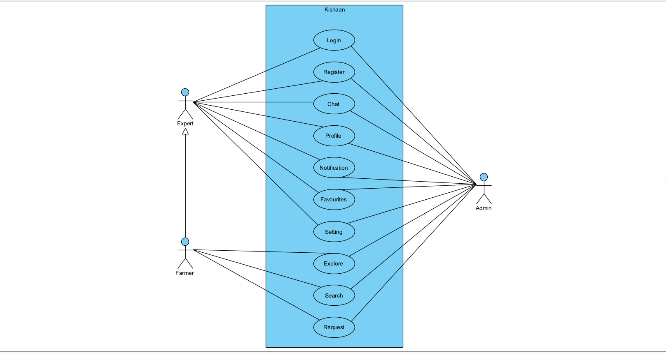

The below is the use case diagram for login. Farmer and expert has to enter their phone number and password to login into the system.

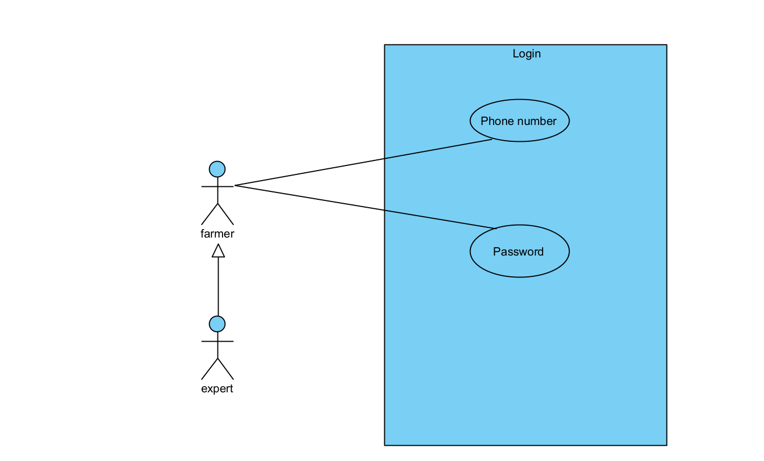

The below is the use case diagram for registration to the system. Farmer have to register with phone and password. Expert have to request registration by providing full name, email, address, phone, password, resume and cover letter.

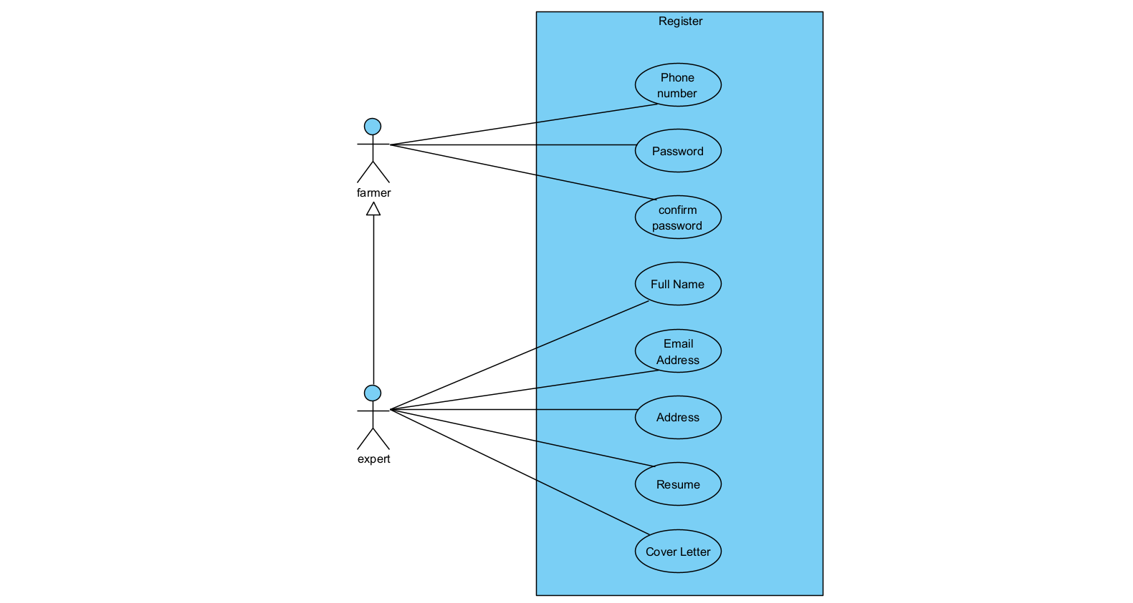

The below use case is a diagram for explore screen of farmers. In explore screen farmers can see recommended experts, top experts and experts by category.

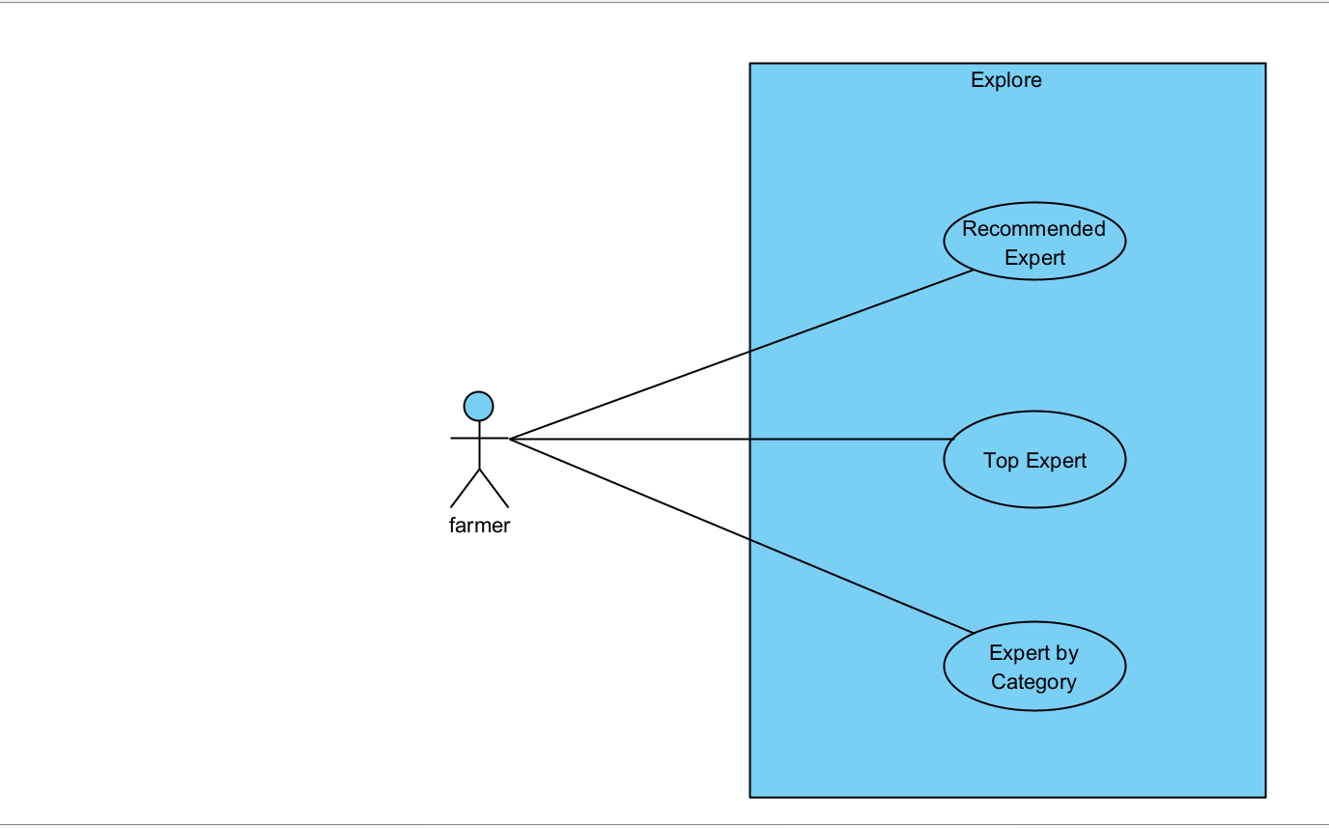

The below is the use case diagram for farmers and experts profile. Farmers and experts both can update their profile picture, bio, address, phone and email. Apart from this experts also can update their degree and tags.

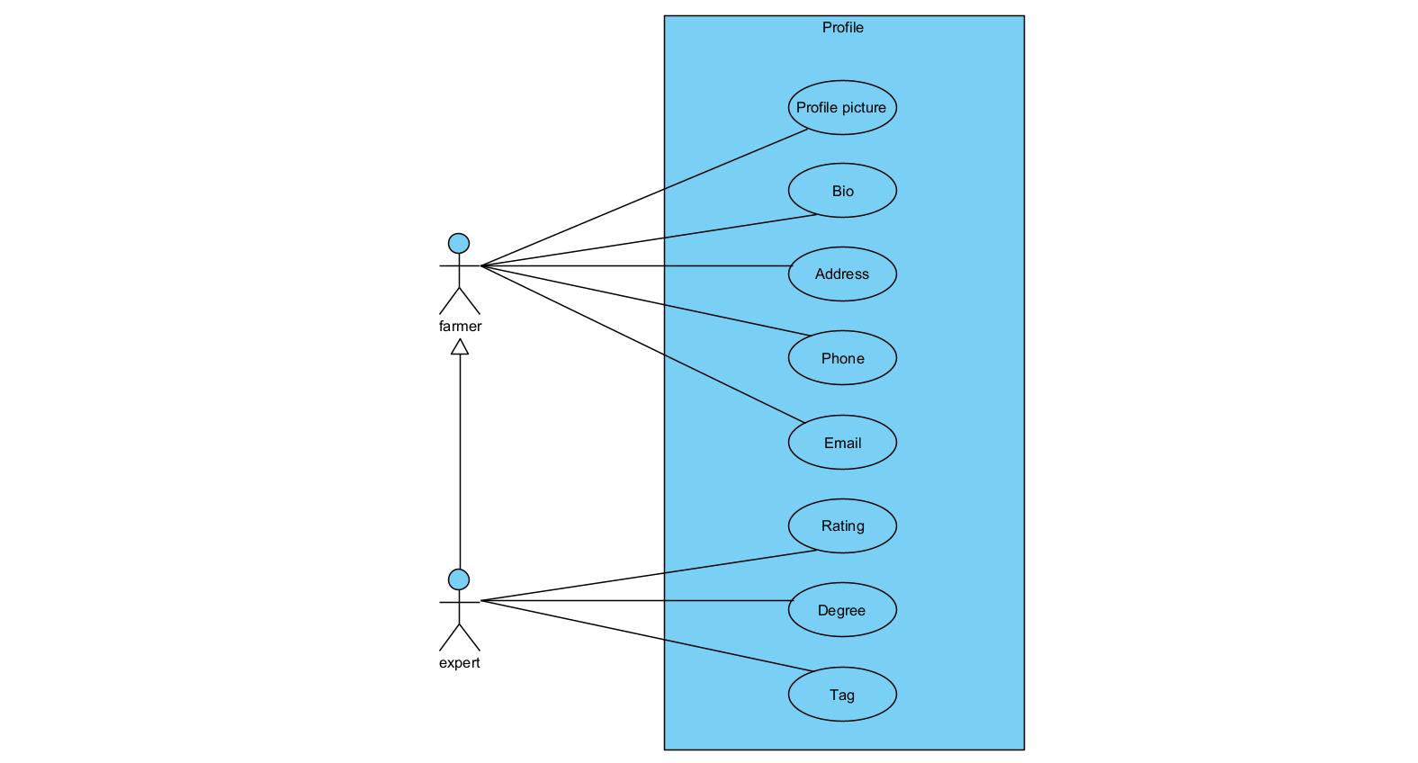

### 5.3.2. Activity diagram

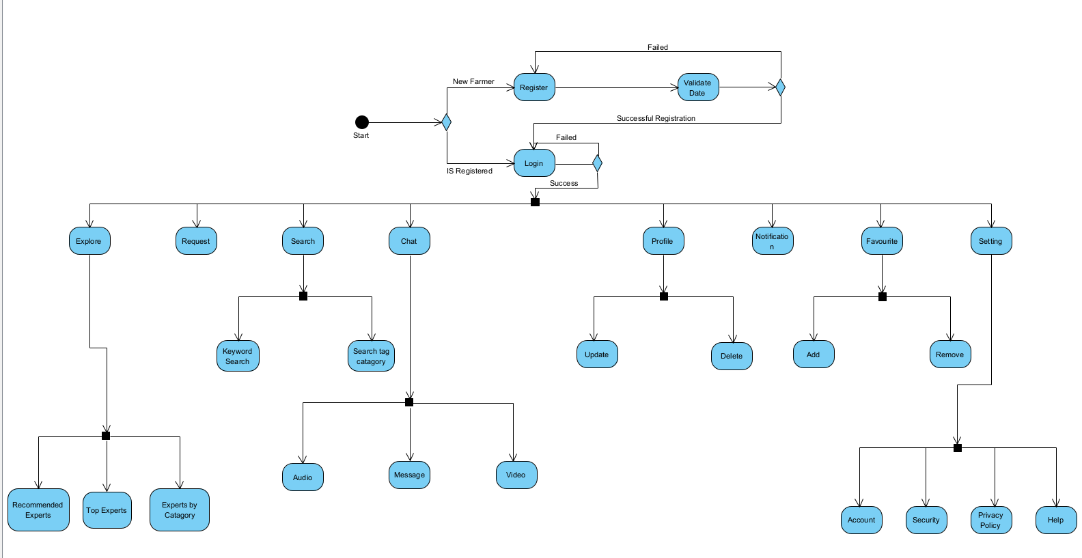

The below is the activity diagram of expert.

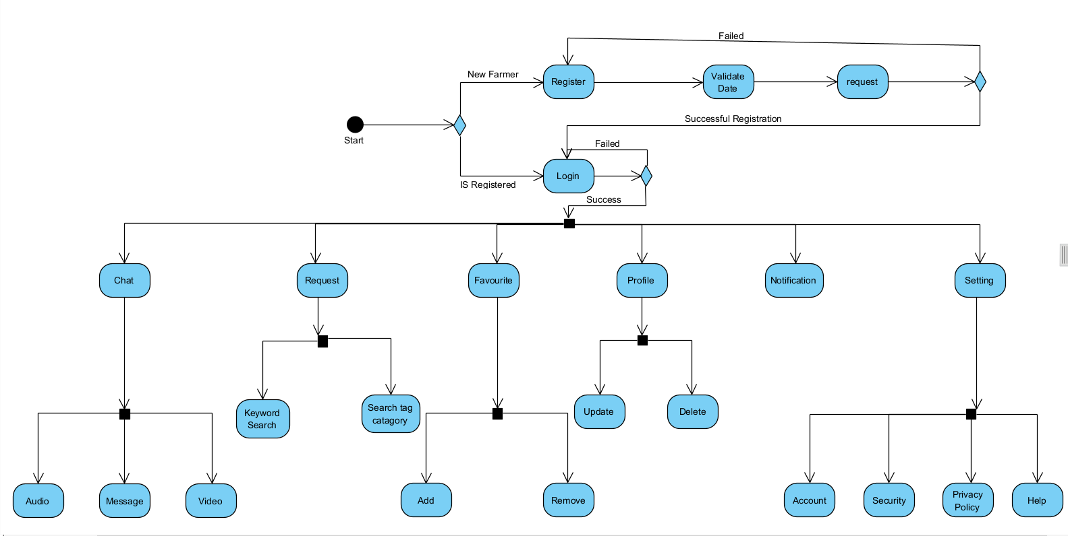

### 5.3.3. Class diagram

### 

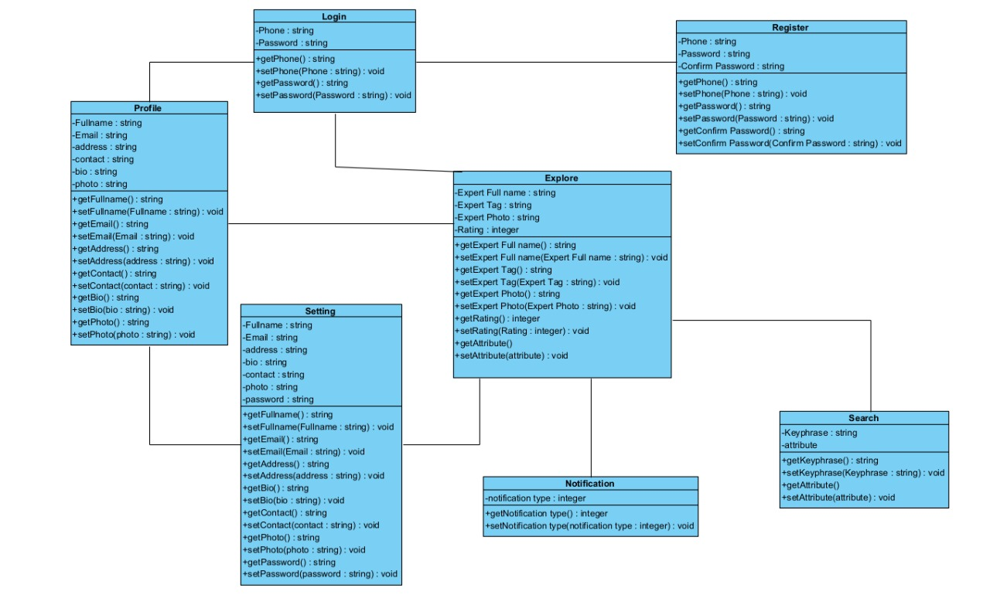

Fig: Class diagram of Farmers.

## 5.4. Prototypes

### 5.4.1. Prototypes of farmers.

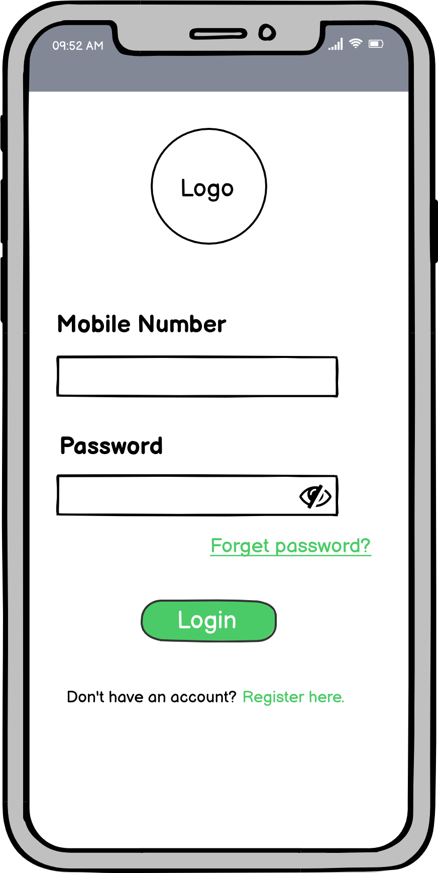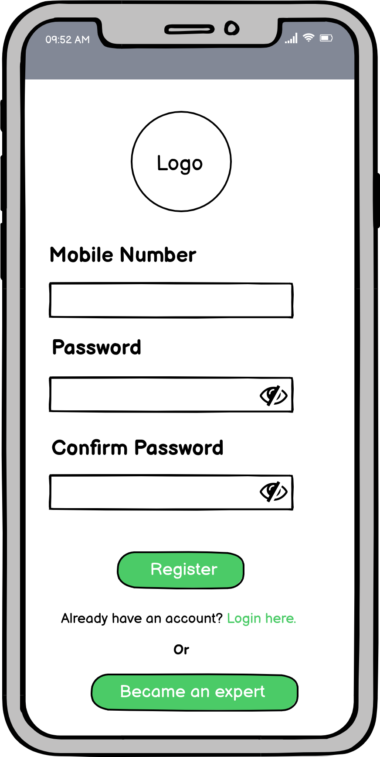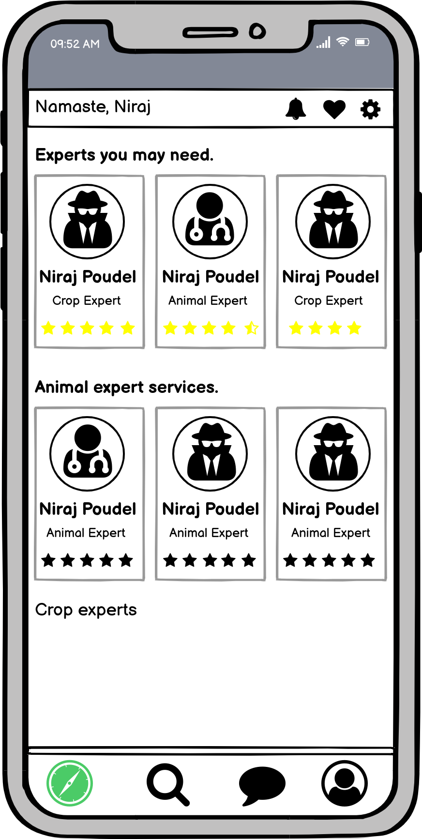

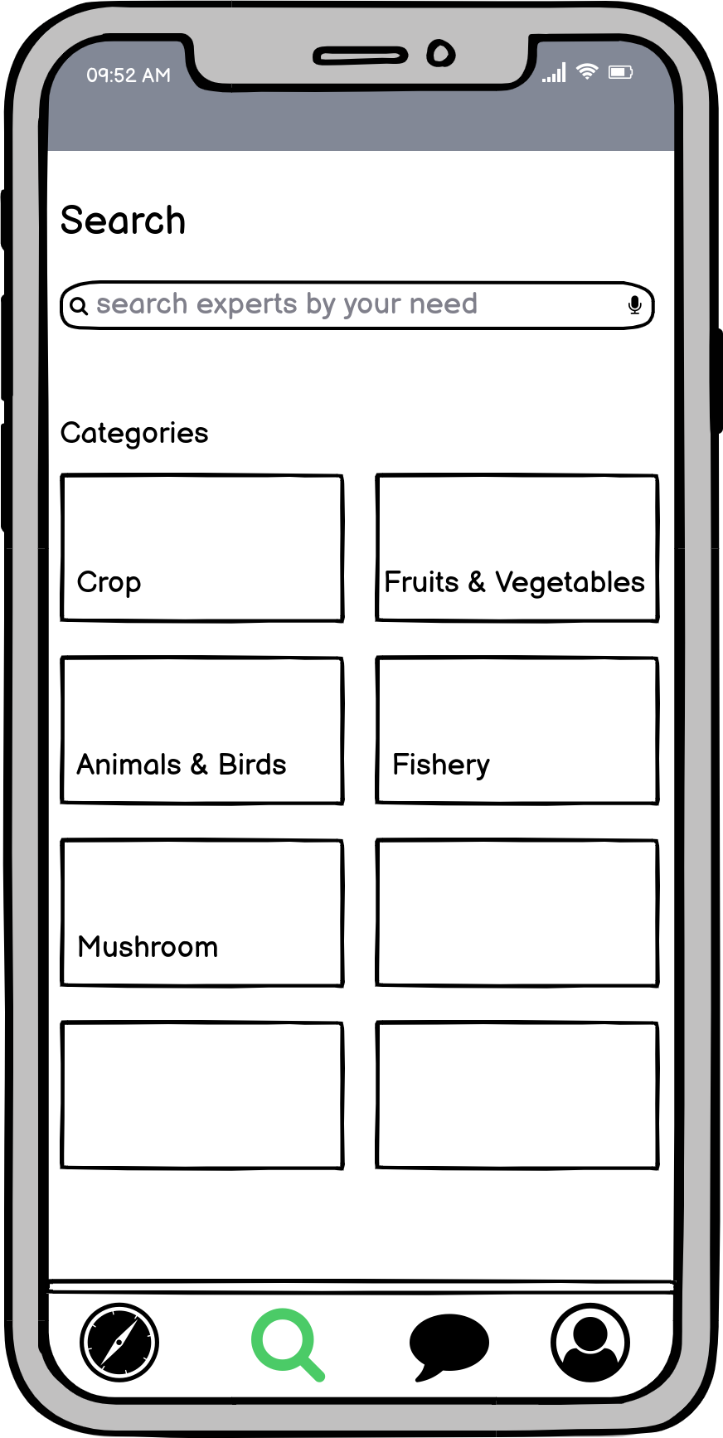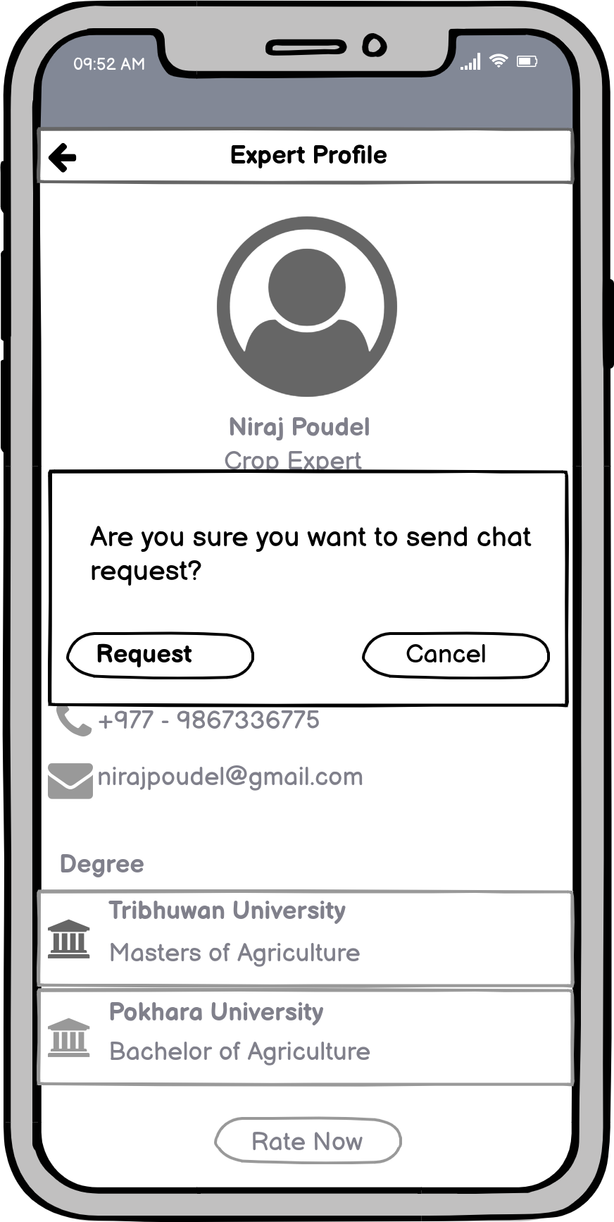

Remaining Prototypes of farmers are in the appendix 1.

### 5.4.2. Prototypes of Experts

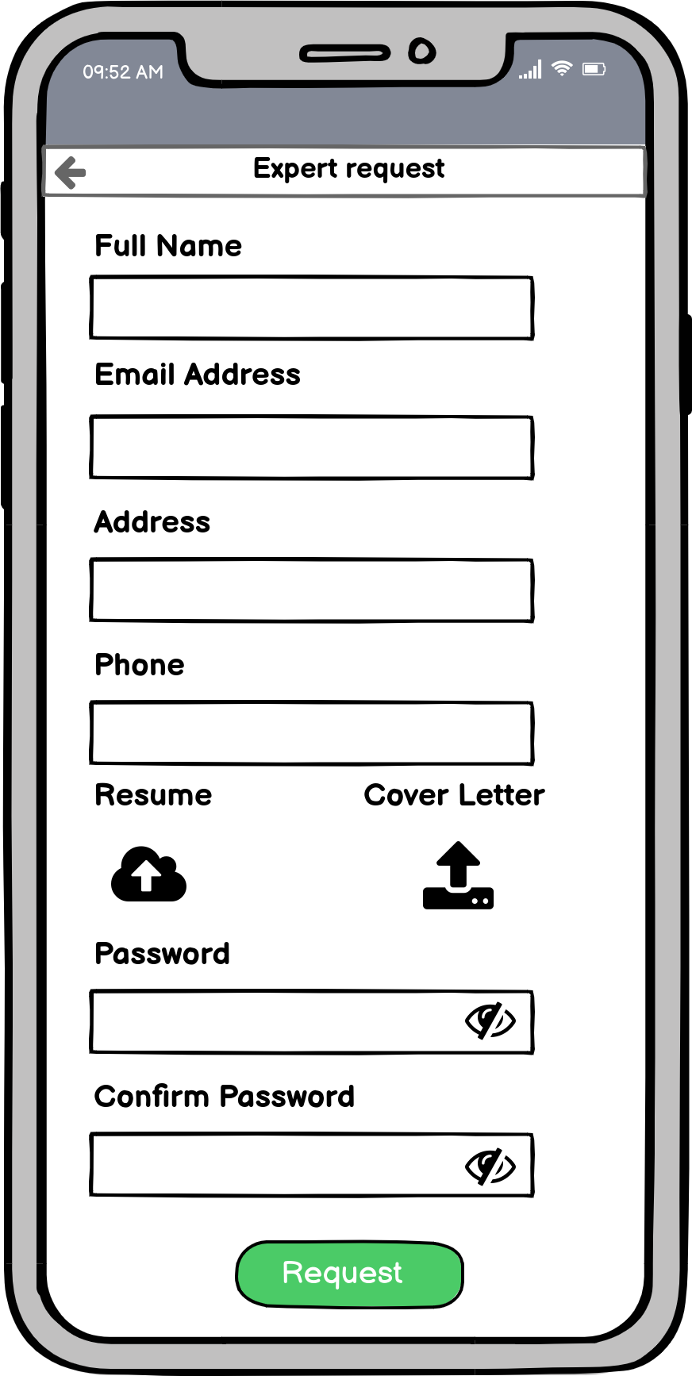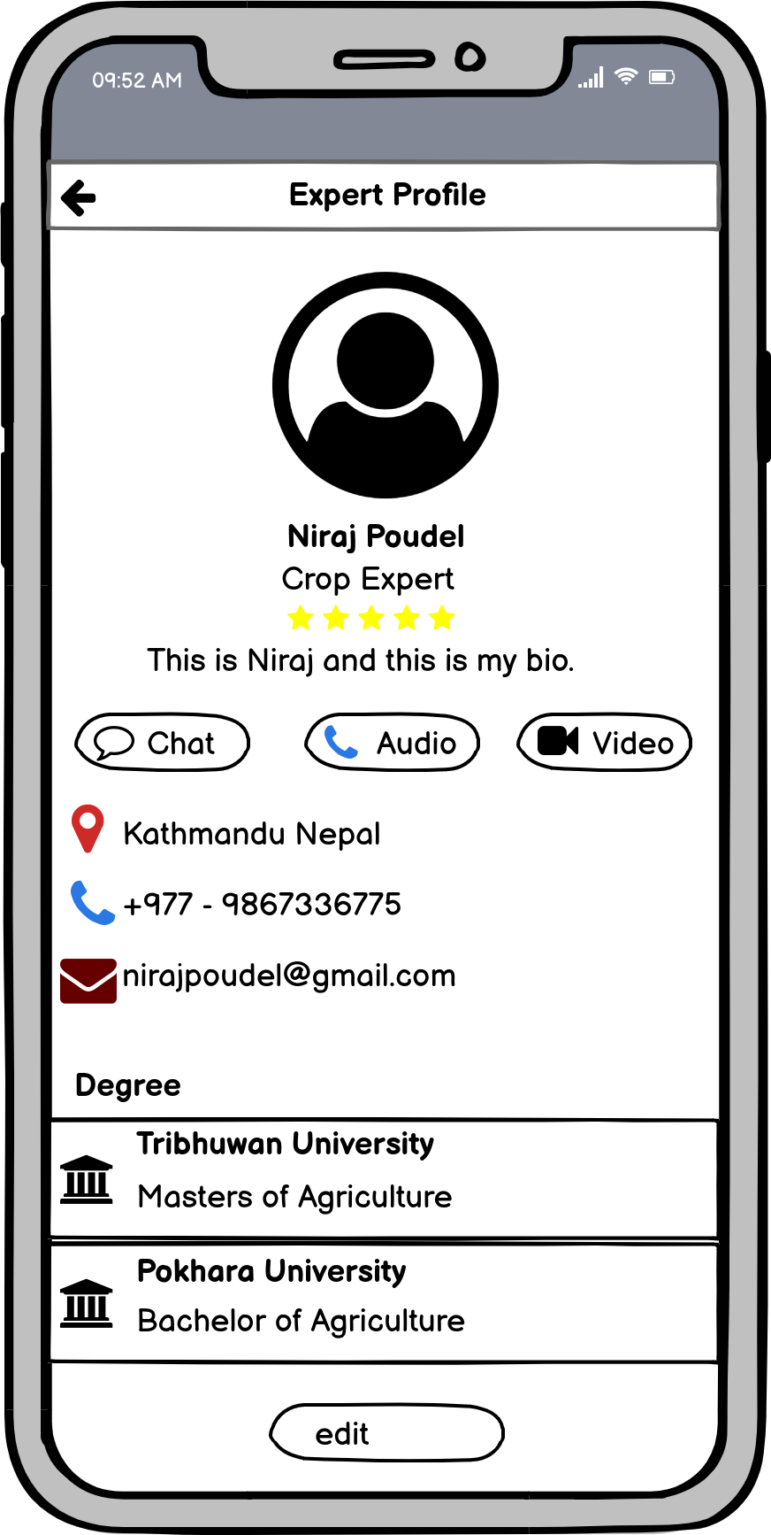



Remaining Prototypes for experts are in the appendix 1.

## 5.5. Testing Strategies

The application will be developed in the upcoming semester. While developing two testing strategies will be applied to test the application, unit testing and integration testing. The use of these two methods throughout the project is described below.

### 5.5.1. Unit testing

During the unit testing individual units of the app like classes, modules, functions etc will be tested one by one. Login and registration modules will be tested in the very first stage. Then other modules such as chats, explore etc will be tested. This will confirm that all the modules are individually working.

### 5.5.2. Integration testing

While doing integration testing multiple modules, classes etc will be tested. Login and registration modules together will be tested. Chat between experts and farmers will be tested and so forth. This will confirm the interconnection between modules are working.

## 5.6. Evaluation Strategies

DECIDE framework is used to evaluate the strategies. According to the DECIDE, at first overall goal of the project is decided. During this phase domain of research has been selected, target audience has been identified, existing products and services in the market are researched. After deciding the particular domain and user base, need of the product is being explored by asking the questions like: need of online platforms?, trust issues in online platforms?, user interfaces and experience?. Right paradigm has been identified during the research and for the development phase as well. After the release of product there might come some practical issues like availability of experts, building trust and so on. Moreover we need to deal with the ethical issues like user privacy. For this user data will be kept safe and private, so that everyone can’t access it. And at the last evaluating, interpreting and presenting the data that will be best suited for the farmers and experts.

# 6. Critical analysis

# 7. Conclusion

Agriculture is the most important domain for every countries in the world. So, it is important to connect farmers and experts for better productivity. If the farmers and experts are connected to each others then farmers can gain skills and take helps to solve their farm problems. On the other hand experts can also get the employment opportunity within the country. From the market research it also concluded that there is a gap between farmers and experts in Nepal. For connecting there are existing methods like direct phone calls or social medias. They have some limitations in some aspects. So, if there is a mobile application that has a wide set of choices for both farmers and experts can be more effective. So with the development of this project ‘Kishaan’, it can help to solve the barrier between farmers and experts by building agricultural community within it.

# 7. References:

*(FAO*. 2021). *Decent Rural Employment | Food and Agriculture Organization of the United Nations*. [online] Available at: https://www.fao.org/rural-employment/en/ [Accessed 30 Nov. 2021].

Nations, U. (2018). *Feeding the World Sustainably | United Nations*. [online] www.un.org. Available at: <https://www.un.org/en/chronicle/article/feeding-world-sustainably>.

Andrade, D., Pasini, F. and Scarano, F.R. (2020). Syntropy and innovation in agriculture. Current Opinion in Environmental Sustainability, [online] 45, pp.20–24. Available at: <https://www.sciencedirect.com/science/article/abs/pii/S1877343520300579>.

Gebbers, R. and Adamchuk, V.I. (2010). Precision Agriculture and Food Security. Science, 327(5967), pp.828–831.

Roser, M. (2019). *Future Population Growth*. [online] Our World in Data. Available at: <https://ourworldindata.org/future-population-growth>.

The World Bank (2018). *Overview*. [online] World Bank. Available at: <https://www.worldbank.org/en/topic/agriculture/overview>.

The World Bank (2018). *Overview*. [online] World Bank. Available at: [https://www.worldbank.org/en/topic/agriculture/overview](https://www.worldbank.org/en/topic/agriculture/overview" \l "1)#1.

TheGlobalEconomy.com. (2020). *GDP share of agriculture by country, around the world*. [online] Available at: <https://www.theglobaleconomy.com/rankings/share_of_agriculture/>.

Nepal Labor Migration Report (2020). [online] Available at: <https://moless.gov.np/wp-content/uploads/2020/03/Migration-Report-2020-English.pdf>.

The Kathmandu Post (2021). Remittance hits Rs961 billion, an all-time high in the time of Covid-19. [online] Available at: https://kathmandupost.com/money/2021/08/22/remittance-hits-rs961-billion-an-all-time-high-in-the-time-of-covid-19 [Accessed 7 Dec. 2021].

Pant, B. (n.d.). Harnessing Remittances for Productive Use in Nepal. [online] Available at: https://www.nrb.org.np/contents/uploads/2019/12/Economic_Review_Occasional_Paper-No_23_April_20111_Harnessing_Remittances_for_Productive_Use_in_NepalBhubanesh-Pant-Ph.D..pdf [Accessed 7 Dec. 2021].

Poudel, B.R. (2020). Absent Nepali agriculture jobs. [online] The Annapurna Express. Available at: https://theannapurnaexpress.com/news/absent-nepali-agriculture-jobs-2526 [Accessed 7 Dec. 2021].

‌The Kathmandu Post (2021). Nepal wants to be an agriculture-driven economy but future of the sector is in crisis. [online] Available at: https://kathmandupost.com/money/2021/06/29/nepal-wants-to-be-an-agriculture-driven-economy-but-future-of-the-sector-is-in-crisis [Accessed 7 Dec. 2021].

The New Humanitarian. (2013). The trouble with Nepal’s agriculture. [online] Available at: https://www.thenewhumanitarian.org/report/97321/analysis-trouble-nepal%E2%80%99s-agriculture [Accessed 7 Dec. 2021].

Kattel, R.R. and Sapkota, M. (2018). Brain drain of agriculture and veterinary graduates to abroad: evidence from Nepal. Agriculture & Food Security, 7(1).

Joshi, K.D., Conroy, C. and Witcombe, J.R. (2019). Agriculture, seed, and innovation in Nepal: industry and policy issues for the future. Gates Open Res, [online] 3(232), p.232. Available at: https://gatesopenresearch.org/documents/3-232 [Accessed 9 Dec. 2021].

Gyawali, P. and Khanal, S. (2021). Overview of Agriculture in Nepal: Issues and strategies to cope with. Fundamental and Applied Agriculture, (0), p.1.

StartupsNepal (2018). Agribusiness and the Problems Facing Agriculture in Nepal. [online] Starups Nepal. Available at: http://www.startupsnepal.com/stories/entry/agribusiness-and-the-problems-facing-agriculture-in-nepal [Accessed 9 Dec. 2021].

Acharya, A.K. and Kafle, N. (2009). Land Degradation Issues in Nepal and Its Management Through Agroforestry. Journal of Agriculture and Environment, 10, pp.133–143.

Gyawali, P. and Khanal, S. (2021). Overview of Agriculture in Nepal: Issues and strategies to cope with. Fundamental and Applied Agriculture, (0), p.1.

USDA (2018). Agriculture Technology | National Institute of Food and Agriculture. [online] Usda.gov. Available at: <https://nifa.usda.gov/topic/agriculture-technology>.

Goedde, L., Katz, J. and Revellat, J. (2020). Agriculture’s connected future: How technology can yield new growth. [online] McKinsey and Company. Available at: https://www.mckinsey.com/industries/agriculture/our-insights/agricultures-connected-future-how-technology-can-yield-new-growth [Accessed 9 Dec. 2021].

FAO (2021). The State of the World’s Land and Water Resources for Food and Agriculture – Systems at breaking point (SOLAW 2021). [online] Available at: https://www.fao.org/documents/card/en/c/cb7654en [Accessed 10 Dec. 2021].

Food and Agriculture Organization of the United Nations (2017). The future of food and agriculture – Trends and challenges. [online] Available at: https://www.fao.org/3/i6583e/i6583e.pdf [Accessed 10 Dec. 2021].

HLPE (2020). FOOD SECURITY AND NUTRITION BUILDING A GLOBAL NARRATIVE TOWARDS 2030. [online] Available at: https://www.fao.org/3/ca9731en/ca9731en.pdf [Accessed 10 Dec. 2021].

Mccalla, A. (2001). Challenges to World Agriculture in the 21st Century. [online] 4(3). Available at: https://s.giannini.ucop.edu/uploads/giannini_public/48/01/4801e886-3406-4e10-b499-ed6147f457e8/spring2001_1.pdf [Accessed 10 Dec. 2021].

Kamilaris, A. and Prenafeta-Boldú, F.X. (2018). A review of the use of convolutional neural networks in agriculture. The Journal of Agricultural Science, [online] 156(3), pp.312–322. Available at: https://pdfs.semanticscholar.org/284a/9cb0b78c17e60597fe92a3d3cca0d7487c13.pdf [Accessed 10 Nov. 2019].

Java T Point (2021). What is Dart Programming. [online] Java T Point. Available at: https://www.javatpoint.com/flutter-dart-programming [Accessed 12 Dec. 2021].

Stevenson, D. (2018). What is Firebase? The complete story, abridged. [online] Medium. Available at: <https://medium.com/firebase-developers/what-is-firebase-the-complete-story-abridged-bcc730c5f2c0>.

TRM Mgmt Group (2021). Visual Paradigm. [online] U.S. Department of Veteran Affairs. Available at: https://www.oit.va.gov/Services/TRM/ToolPage.aspx?tid=10208# [Accessed 17 Dec. 2021].

Hilliard, A. (2014). Why Mobile Applications Are Important; Especially Its Development. [online] Acclerance. Available at: https://www.accelerance.com/blog/why-is-mobile-app-development-so-important-today [Accessed 18 Dec. 2021].

Qamadness (2021). How to Write a Good Mobile App Testing Strategy in 2021. [online] QA Madness. Available at: https://www.qamadness.com/how-to-write-a-good-mobile-app-testing-strategy-in-2021/ [Accessed 28 Dec. 2021].

# 8. Appendix:

## **8.1. Appendix 1: Prototypes**

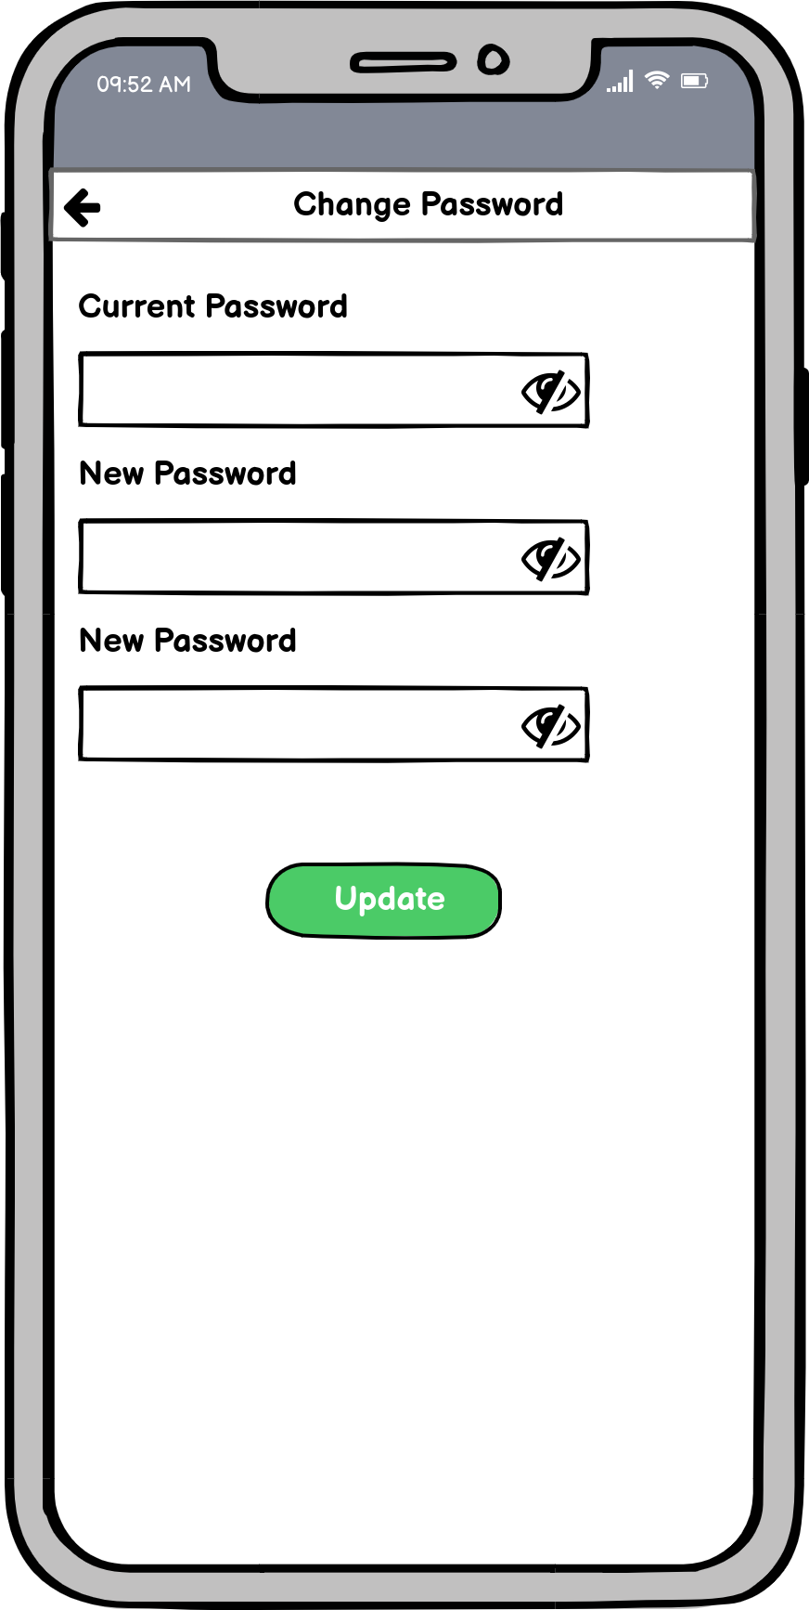



## **8.2. Appendix 2: Progress Reports**

